 | ITEM NUMBER: CM-01980
REV: |  | DESCRIPTION: | ECO: | DATE: | APPROVED:
0.1 |  | SENT TO CUSTOMER FOR REVIEW |  | 09/09/2024 | K. FOSMARK
0.2 |  | DESIGN UPDATES SENT TO CUSTOMER FOR REVIEW |  | 12/13/2024 | J. PARKER
0.3 |  | UPDATES FOR INTERNAL INTERFACES, NEXT REVISION REQUIRES HEATER PINOUT FINALIZATION AND FEEDBACK FROM VENDOR |  | 5/13/2025 | J. PARKER
0.4 |  | UPDATED CONNECTOR PINOUTS FOR J2, J5, AND J6 |  | 5/16/2025 | K. FOSMARK
0.5 |  | UPDATED WITH HEATER AND THERMISTORS FOR OPTICAL ASSEMBLY, HEATER PARAMETERS CORRECTED |  | 6/17/2025 | K. FOSMARK
0.6 |  | FINAL QUARTUS REVIEW PRIOR TO REV 1 RELEASE |  | 7/16/2025 | D. GOEL

TABLE OF CONTENTS
1.0 INTRODUCTION 5
1.1. PURPOSE 5
1.2. SCOPE 5
1.3. USAGE 5
1.4. CONTROL AUTHORITY 5
1.5. STANDARDS AND SPECIFICATIONS 5
2.0 APPLICABLE DOCUMENTS 5
2.1. INTERNAL DOCUMENTATION 5
2.2. EXTERNAL DOCUMENTATION 6
3.0 FARSIGHT SYSTEM OVERVIEW 6
3.1. TURION MISSION AND COMPANY PROFILE 6
3.2. FARSIGHT COMPLIANCE 6
4.0 EXTERNAL ELECTRICAL INTERFACE DEFINITIONS 7
4.1 BLOCK DIAGRAM 7
4.2 SIGNAL DEFINITIONS 8
4.2.1 POWER SUPPLY 8
4.2.2 RS422 INTERFACE 8
4.2.3 Pulse per Second (PPS) INTERFACE 8
4.2.4 10MHz INTERFACE 9
4.2.5 TRIG INTERFACE 9
4.2.6 INTERRUPT INTERFACES 9
4.2.7 GENERAL PURPOSE INTERFACES 10
4.2.8 PROGRAMMING INTERFACE 10
4.2.9 ETHERNET INTERFACES 11
4.2.10 PCIe INTERACE 11
4.2.11 HEATER AND THERMISTOR INTERFACE 12
4.3 CONNECTOR INTERFACE PINOUT DESCRIPTIONS 14
4.3.1 J1: TELEMETRY AND CONTROL 15
4.3.2 J2: PCIe SERIAL DATA 16
4.3.3 J3: Ethernet 1 17
4.3.4 J4: Ethernet 2 17
4.3.5 J5: POWER 18
4.3.6 QJ1 -QJ6: OTA HEATERS AND THERMISTORS 19
6.0 GROUNDING 21
7.0 INTERNAL ELECTRICAL INTERFACE DEFINITIONS 22
7.1 J6: Focusing Mechanism Interface 22
7.2 Focusing Mechanism Harness 22
7.3 J7: Sensor Board Interface 23

LIST OF FIGURES
Figure 4-1: FARSIGHT Electrical Interface Block Diagram 7
Figure 7-1: Focusing mechanism harness illustration 23

LIST OF TABLES
Table 2-1: Applicable TURION Documentation 5
Table 2-2: Applicable External Documentation 6
Table 4-1: Power Supply Interface Pins 8
Table 4-2: RS422 Interface Pins 8
Table 4-3: PPS Interface Pins 9
Table 4-4: 10 MHz Interface Pins 9
Table 4-5: Trig Interface Pins 9
Table 4-6: Interrupt Interface Pins 9
Table 4-7: General Purpose Interface Input Parameters 10
Table 4-8: General Purpose Interface Output Parameters 10
Table 4-9: Programming Interface Input Parameters 10
Table 4-10: Programming Interface Output Parameters 10
Table 4-11: Ethernet Interface Pins 11
Table 4-12: High-Speed PCIe Interface Pins 12
Table 4-13: High-Speed PCIe Interface Pins 12
Table 4-14: Focal Plane PCB Heater Interface Pins 12
Table 4-15: Focal Plane PCB Thermistor Interface Pins 13
Table 4-16: Optical Assembly Heater Interface Pins 13
Table 4-: Optical Assembly Thermistor Interface Pins 13
Table 4-14: Telemetry and Control Connector Pinout 15
Table 4-15: High-Speed Serial Data Connector Pinout 16
Table 4-16: Ethernet 1 Connector Pinout 17
Table 4-17: Ethernet 2 Connector Pinout 17
Table 4-18: Power Connector Pinout 18
Table 7-1: Focusing Mechanism Interface Pinout 22
Table 7-2: Sensor Board Interface Pinout 23

LIST OF ACRONYMS
- ECO: Engineering Change Order
- FPGA: Field Programmable Gate Array
- GPI: General Purpose Input
- GPIO: General Purpose Input/Output
- GPO: General Purpose Output
- ICD: Interface Control Document
- LVCMOS: Low-Voltage Complementary Metal-Oxide-Semiconductor
- LVDS: Low-Voltage Differential Signaling
- PCB: Printed Circuit Board
- PPS: Pulse Per Second
- SERDES: Serializer/De-serializer
- TBA: To be Added
- TBD: To be Determined
- TBR: To be Revised

- INTRODUCTION
This document defines the interface functions and configuration parameters of the FARSIGHT electrical system as a payload of a DROID bus.

For Payload usage guidelines, operations, limitations, implementation, integration services, testing services, see the DROID.alpha Host Payload User Guide. The User Guide provides a complete description of how to implement a Payload System on TURION’s Hosted Payload Service.

  - PURPOSE
This document serves as an overview of the electrical system for the FARSIGHT telescope. This Interface Control Document (ICD) is not a standalone document and must be used in conjunction with the documents listed in section 2.0 Applicable Documents to ensure successful payload operations.

  - SCOPE
This document defines the electrical interfaces to the FARSIGHT imaging payload.
Definitions include:
- Control interface signal definitions, polarities, and levels are defined.
- Power supply voltage and current specifications.
- Heater and thermistor electrical interfaces.
- Connector pinout definitions

  - USAGE
This document is to be used by designers for the FARSIGHT payload electrical system to guide in the development and verification of FARSIGHT design’s conformance of integrating onto the DROID.Alpha bus.

  - CONTROL AUTHORITY
Upon release of version 1.0, this document is under the TURION quality control system and shall propose changes in accordance with the internal Engineering Change Order (ECO) process. Prior to version 1.0 this document is considered under a DRAFT status.

  - STANDARDS AND SPECIFICATIONS
The document adheres to multiple MIL and NASA standards and specifications, employing standard space industry nomenclature. The end users of this document are assumed to be Space Industry professionals.

- APPLICABLE DOCUMENTS
  - INTERNAL DOCUMENTATION
The following TURION documents and authorized changes form a part of this document.
Table 2-1: Applicable TURION Documentation
Identifier | Document Title
CM-00945 | EXPORT CONTROL, GUIDELINES, DOCUMENT MARKING

  - EXTERNAL DOCUMENTATION
TURION uses External Documents to implement industry standard practices to minimize payload integration complexity.
Table 2-2: Applicable External Documentation
Authoring Entity | Identifier | Document Title
NASA | NASA-HDBK-4001 | ELECTRICAL GROUNDING ARCHITECTURE FOR UNMANNED SPACECRAFT

- FARSIGHT SYSTEM OVERVIEW
  - TURION MISSION AND COMPANY PROFILE
TURION was founded to accelerate the commercialization of space while focusing on key technological risks toward advancement of the greater vision of a prosperous and stable space economy. To address these risks, TURION uses a hardware-first approach to rapidly develop and iterate on space vehicles using a capability-based architecture to reduce risk and iteration cycle time.
  - FARSIGHT COMPLIANCE
FARSIGHT must adhere to the guidelines and requirements specified in this document and the DROID.Alpha Hosted Payload User Guide. This ensures successful integration and operation within the DROID.Alpha Satellite Bus Payload environment.

EXTERNAL ELECTRICAL INTERFACE DEFINITIONS

4.1 BLOCK DIAGRAM
FARSIGHT interface illustrated in block diagram below (Reference Figure 41). The electrical interface is circled in red.
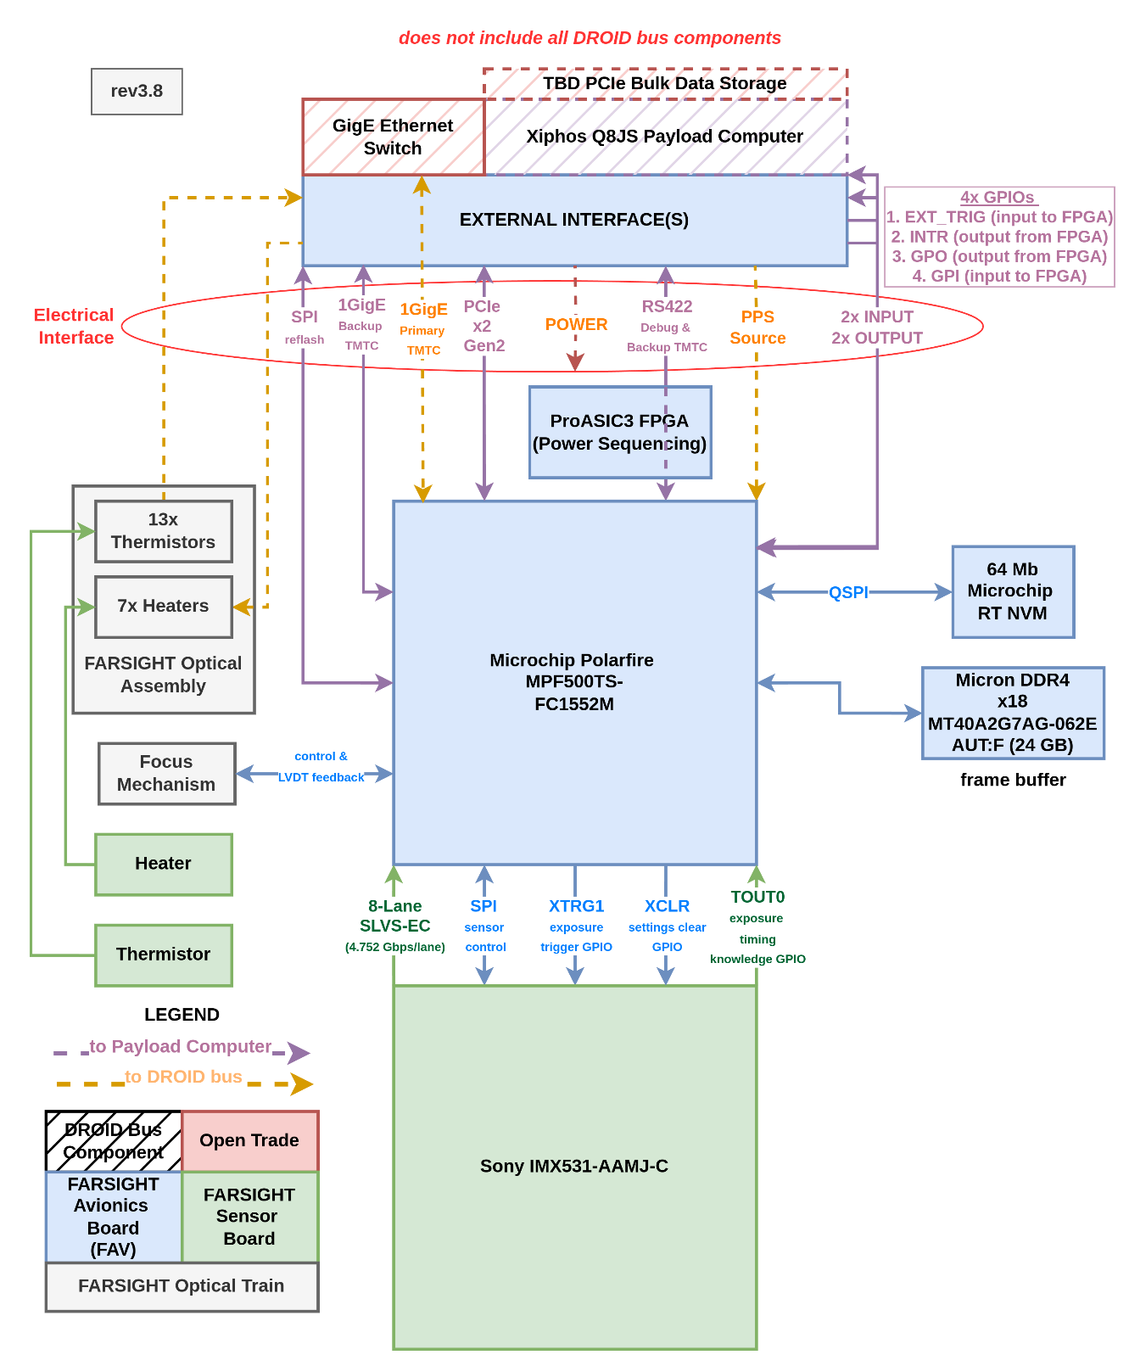-
Figure 4-1: FARSIGHT Electrical Interface Block Diagram

SIGNAL DEFINITIONS
This section defines the electrical interfaces to FARSIGHT. Characteristics of the power and control interfaces and communications protocols and standards used are defined. Connector pinout is defined in section 4.3.

POWER SUPPLY
FARSIGHT requires one 28V power rail. All internal voltages are internally generated from this 28V rail. Power is supplied across PWR/PGND pins on the electrical interface. When power is within the Over/under voltage thresholds, FARSIGHT enters its lowest power operating mode and will respond to commands.
Table 4-1: Power Supply Interface Pins
Power Supply Pins
Power Supply Positive | PWR
Power Supply Return ground | PGND
Power Supply Absolute Maximum Ratings
Voltage Range | -50V to 50V
Over/under voltage thresholds | 20V to 38V
Power Supply Recommended Operating Conditions
Voltage Range | 24V to 34V
Max current | 1.2A
Max power | 35W
Max inrush current | 2.5A

RS422 INTERFACE
FARSIGHT is primarily controlled using a full duplex RS422 interface running at 115.2 kbaud. The software ICD for FARSIGHT defines the protocol implemented.
The receive RS422 (RS422_BUS_TO_FARSIGHT_P/N) is terminated with a 100 ohm resistor.
Table 4-2: RS422 Interface Pins
RS422 Pins
RS422 inputs to FARSIGHT | RS422_BUS_TO_FARSIGHT_P  RS422_BUS_TO_FARSIGHT_
RS422 outputs from FARSIGHT | RS422_FARSIGHT_TO_BUS_P  RS422_FARSIGHT_TO_BUS_N
Electrical Signaling standard | ANSI/TIA/EIA-422-B
Receiver termination resistance | 100 ohm
Baud rate (default) | 115.2 kbaud

Pulse per Second (PPS) INTERFACE
Pulse per Second (PPS) is the one pulse per second timing reference from the bus. It is electrically using a differential Low-Voltage Differential Signaling (LVDS) receiver, including 100 ohm termination resistor. The rising edge (PPS_P going from low to high and PPS_N going from high to low) is the timing edge used for synchronization purposes.

Table 4-3: PPS Interface Pins
PPS Pins
PPS inputs to FARSIGHT | PPS_P  PPS_N
Electrical Signaling standard | LVDS TIA/EIA-644
Termination resistance | 100 ohm
Minimum PPS pulse width | 10 ms

10MHz INTERFACE
10MHz is a reference clock from the bus (synchronized to PPS). It is electrically using a differential LVDS receiver, including 100 ohm termination resistor. Supply of 10MHz is optional and this port can be left open.
Table 4-4: 10 MHz Interface Pins
10MHz Pins
10MHz inputs to FARSIGHT | 10MHZ_P  10MHZ_N
Electrical Signaling standard | LVDS TIA/EIA-644
Termination resistance | 100 ohm

TRIG INTERFACE
TRIG is a trigger input interface to FARSIGHT that can be used to trigger FARSIGHT to for example take a picture at that exact time. TRIG is electrically using a differential LVDS receiver, including 100 ohm termination resistors. The rising edge (TRIG_P going from low to high and TRIG_N going from high to low) is the active trigger edge used. Use of TRIG is optional and this port can be left open.
Table 4-5: Trig Interface Pins
TRIG Pins
TRIG inputs to FARSIGHT | TRIG_P  TRIG_N
Electrical Signaling standard | TIA/EIA-644
Termination resistance | 100 ohm
Minimum TRIG pulse width | 10 ms

INTERRUPT INTERFACES
INTERRUPT is an output from FARSIGHT that can be used to alert the host system to an urgent condition. INTERRUPT is electrically using a differential LVDS transmitter. Logic high (INTERRUPT_P high and INTERRUPT_N low) indicates an active interrupt condition. Acknowledging the interrupt condition is documented in the software ICD.
Use of INTERRUPT is optional and this port can be left open. If used, the receiver should be terminated with a 100 termination resistor.
Table 4-6: Interrupt Interface Pins
TRIG Pins
INTERRUPT outputs from FARSIGHT | INTERRUPT_P  INTERRUPT_N
Electrical Signaling standard | LVDS TIA/EIA-644
Expected termination resistance | 100 ohm

GENERAL PURPOSE INTERFACES
For flexibility during the firmware and software development process, a General Purpose Input (GPI) and a General Purpose Output (GPO) have been allocated for use cases that are to be determined. The General Purpose Input (GPI) is a general-purpose input to the FARSIGHT camera. The General Purpose Output (GPO) is a general-purpose out from the FARSIGHT camera.
GPI and GPO are electrically using differential LVDS signaling. The GPI signal includes a 100 ohm termination. If GPO is used, the receiving end should be terminated with 100 ohm.
Connecting to these ports is optional and they can be left open.
Table 4-7: General Purpose Interface Input Parameters
General Purpose input
General Purpose input to FARSIGHT | GPIN_P  GPIN_N
Electrical Signaling standard | LVDS TIA/EIA-644
Termination resistance | 100 ohm

Table 4-8: General Purpose Interface Output Parameters
General Purpose output
General Purpose output from FARSIGHT | GPOUT_P  GPOUT_N
Electrical Signaling standard | LVDS TIA/EIA-644
Expected termination resistance | 100 ohm

PROGRAMMING INTERFACE
For the purpose of being able to reprogram the Field Programmable Gate Array (FPGA) inside FARSIGHT, a programming SPI interface is available on the module interface. Programming scheme documented in Software ICD.
Electrically, the four SPI signals are electrically using differential LVDS signaling.
Connecting to these ports is optional and they can be left open. (An open input is pulled to safe state inside Farsight.)
Table 4-9: Programming Interface Input Parameters
Programming inputs
Programming inputs to FARSIGHT (SPI inputs) | PR_SS_P/PR_SS_N  PR_SDI_P/PR_SDI_N  PR_SCK_P/PR_SCK_N
Electrical Signaling standard | LVDS TIA/EIA-644
Termination resistance | 100 ohm

Table 4-10: Programming Interface Output Parameters
Programming outputs
Programming output from FARSIGHT (SPI output) | PR_SDO_P  PR_SDO_N
Electrical Signaling standard | LVDS TIA/EIA-644
Expected termination resistance | 100 ohm

ETHERNET INTERFACES
This interface provides the primary method of data transfer off the FARSIGHT payload. It operates on the 1000BASE-T standard.
This interface is magnetically isolated and there are two ports provided for redundancy and increased data transfer rate.
Table 4-11: Ethernet Interface Pins
Ethernet Interfaces
Ethernet 1 pins | ETH1_MX1_P  ETH1_MX1_N  ETH1_MX2_P  ETH1_MX2_N  ETH1_MX3_P  ETH1_MX3_N  ETH1_MX4_P  ETH1_MX4_N
Ethernet 2 pins | ETH2_MX1_P  ETH2_MX1_N  ETH2_MX2_P  ETH2_MX2_N  ETH2_MX3_P  ETH2_MX3_N  ETH2_MX4_P  ETH2_MX4_N
Ethernet standard | IEEE 802.3 1000BASE-T

PCIe INTERACE
The PCIe interface provides an additional even higher speed data interface for the FARSIGHT payload. FARSIGHT functions as a “PCIe x2 Gen2 Endpoint”.
Two bidirectional “SERDES” (serializer/deserializer) ports (a total of 4 signal pairs) from the FPGA comprise the data links of the PCIe.
An additional SERDES pair is an optional reference clock input to the FPGA.
And furthermore, the PCIe Reset signal from the root complex is also an input to FARSIGHT. PCIE_NRESET is electrically using a differential LVDS receiver, including 100 ohm termination resistor. Logic low (PCIE_NRESET_P low and PCIE_NRESET_N high) indicates an active reset condition.

Table 4-12: High-Speed PCIe Interface Pins
High-speed PCIe SERDES interfaces
PCIe lane 0, input pins | PCIE0_RX_P  PCIE0_RX_N
PCIe lane 0, output pins | PCIE0_TX_P  PCIE0_TX_N
PCIe lane 1, input pins | PCIE1_RX_P  PCIE1_RX_N
PCIe lane 1, output pins | PCIE1_TX_P  PCIE1_TX_N
PCIe Reference clock input pins | PCIE_REF_CLK_P  PCIE_REF_CLK_N
Electrical Signaling standard | “SerDes” TIA/EIA-644
Termination resistance | On-chip termination

Table 4-13: High-Speed PCIe Interface Pins
High-speed PCIe SERDES interfaces
PCIe Reset input pins | PCI_NRESET_P  PCI_NRESET_N
Electrical Signaling standard | LVDS TIA/EIA-644
Termination resistance | 100 ohm

Since these signals are terminated in the FPGA inside FARSIGHT, it is possible to implement other serial protocols if needed in the future. Some other possible protocols:
- Aurora
- LightFast
- 10GBASE-KR/R
- SATA

HEATER AND THERMISTOR INTERFACE
FARSIGHT has internal heaters and internal thermistors mounted on the telescope structure and the Focal Plane Printed Circuit Board (PCB). These are all made available for external thermal management from the host vehicle bus.
The Heater and Thermistor parameters for the Focal Plane PCB thermal management are given in table below:
Table 4-14: Focal Plane PCB Heater Interface Pins
Focal Plane Heater
Pins | IMX_HEATER_P  IMX_HEATER_N
Voltage Range | 24V to 34V
Heater nominal resistance | 990-1010 ohm
Location | Focal Plane PCB

Table 4-15: Focal Plane PCB Thermistor Interface Pins
Focal Plane Thermistor
Pins | IMX_THERM_P  IMX_THERM_N
Thermistor | Vishay NTCS0603E3222FMT

Note: Leads of each heater and each thermistor have resistive bleed-path to ground to allow no-connect these signals.
The heaters and thermistors on the telescope optical assembly
Table 4-16: Optical Assembly Heater Interface Pins
Heaters Zones 1-6
Pins | HTRxx_P  HTRxx_N
Voltage Range | 24V to 34V
Heater nominal resistance | 39-157 ohm (depending on channel)
Heater zone minimum resistance | >17 ohm
Location | Optical Assembly

Table 4-: Optical Assembly Thermistor Interface Pins
Optical Assembly Thermistors
Pins | THERMxx_P  THERMxx_N
Thermistor | Omega TH-44004-xx-T

CONNECTOR INTERFACE PINOUT DESCRIPTIONS
This section defines the connector interfaces on FARSIGHT and their pinout.
- J1: Telemetry and Control
- J2: High-speed Serial Data
- J3: Ethernet 1
- J4: Ethernet 2
- J5: Power
- QJ1-6: Optical Assembly Heaters and thermistors

The following subsections define each connector.

J1: TELEMETRY AND CONTROL
25 pin female Micro-D with jack posts.
(Omnetics MMDS-025-VV-N01 (equivalent), mating example: Omnetics MMDP-025-SS-N02)
Table 4-14: Telemetry and Control Connector Pinout
Pin | Pin Name | Description
1 | RS422_BUS_TO_FARSIGHT_P | RS422 telemetry, input
2 | RS422_BUS_TO_FARSIGHT_N | RS422 telemetry, input
3 | PPS_P | Pulse Per Second timing pulse, LVDS, input
4 | PPS_N | Pulse Per Second timing pulse, LVDS, input
5 | 10MHZ_P | 10MHz clock, LVDS, input
6 | 10MHZ_N | 10MHz clock, LVDS, input
7 | GPOUT_P | General Purpose Output, LVDS, output
8 | GPOUT_N | General Purpose Output, LVDS, output
9 | PR_SS_P | Programming SPI Chip Select, LVDS, input
10 | PR_SS_N | Programming SPI Chip Select, LVDS, input
11 | PR_SDI_P | Programming SPI MOSI, LVDS, input
12 | PR_SDI_N | Programming SPI MOSI, LVDS, input
13 | CHAS | Chassis Shield
14 | RS422_FARSIGHT_TO_BUS_P | RS422 telemetry, output
15 | RS422_FARSIGHT_TO_BUS_N | RS422 telemetry, output
16 | TRIG_P | External Trigger, LVDS, input
17 | TRIG_N | External Trigger, LVDS, input
18 | INTERRUPT_P | INTERRUPT, LVDS, output
19 | INTERRUPT_N | INTERRUPT, LVDS, output
20 | GPIN_P | General Purpose Input, LVDS, input
21 | GPIN_N | General Purpose Input, LVDS, input
22 | PR_SDO_P | Programming SPI MISO, LVDS, output
23 | PR_SDO_N | Programming SPI MISO, LVDS, output
24 | PR_SCK_P | Programming SPI clock, LVDS, input
25 | PR_SCK_N | Programming SPI clock, LVDS, input

J2: PCIe SERIAL DATA
26 pin Samtec AcceleRate ARC6 connector.
(Samtec ARF6-08-S-D-A-K-TR, mating example: Samtec ARC6-08-06.0-LU-LD-2-1)
Table 4-15: High-Speed Serial Data Connector Pinout
Pin Number | Pin Name | Description
1 | CHAS |  | Chassis Shield
3 | PCIE_REF_CLK_N |  | PCIe Reference Clock Negative, SerDes, input
5 | PCIE_REF_CLK_P |  | PCIe Reference Clock Positive, SerDes, input
7 | CHAS |  | Chassis Shield
9 | PCIE_NRESET_N |  | PCIe nRESET Negative, LVDS, input
11 | PCIE_NRESET_P |  | PCIe nRESET Positive, LVDS, input
13 | CHAS |  | Chassis Shield
15 | PCIE1_RX_P |  | PCIe 1 Positive, SerDes, input
17 | PCIE1_RX_N |  | PCIe 1 Negative, SerDes, input
19 | CHAS |  | Chassis Shield
21 | PCIE0_RX_P |  | PCIe 0 Positive, SerDes, input
23 | PCIE0_RX_N |  | PCIe 0 Negative, SerDes, input
25 | CHAS |  | Chassis Shield
2 | CHAS |  | Chassis Shield
4 | PCIE0_TX_N |  | PCIe 0 Negative, SerDes, output
6 | PCIE0_TX_P |  | PCIe 0 Positive, SerDes, output
8 | CHAS |  | Chassis Shield
10 | PCIE1_TX_N |  | PCIe 1 Negative, SerDes, output
12 | PCIE1_TX_P |  | PCIe 1 Positive, SerDes, output
14 | CHAS |  | Chassis Shield
16 | UNUSED_P |  | Unused
18 | UNUSED_N |  | Unused
20 | CHAS |  | Chassis Shield
22 | UNUSED_P |  | Unused
24 | UNUSED_N |  | Unused
26 | CHAS |  | Chassis Shield

J3: Ethernet 1
9 pin male Micro-D.
(Omnetics MMDP-009-VV-N01 (equivalent), mating example: Omnetics MMDS-009-SS-N02)
Table 4-16: Ethernet 1 Connector Pinout
Pin Number |  | Pin Name | Description
1 |  | ETH1_MX4_N | IEEE 802.3, MX4-
 | 6 | ETH1_MX4_P | IEEE 802.3, MX4+
2 |  | ETH1_MX3_N | IEEE 802.3, MX3-
 | 7 | ETH1_MX3_P | IEEE 802.3, MX3+
3 |  | SHLD | Chassis Shield
 | 8 | ETH1_MX2_N | IEEE 802.3, MX2-
4 |  | ETH1_MX2_P | IEEE 802.3, MX2+
 | 9 | ETH1_MX1_N | IEEE 802.3, MX1-
5 |  | ETH1_MX1_P | IEEE 802.3, MX1+

J4: Ethernet 2
9 pin male Micro-D.
(Omnetics MMDP-009-VV-N01 (equivalent), mating example: Omnetics MMDS-009-SS-N02)
Table 4-17: Ethernet 2 Connector Pinout
Pin Number |  | Pin Name | Description
1 |  | ETH2_MX4_N | IEEE 802.3, MX4-
 | 6 | ETH2_MX4_P | IEEE 802.3, MX4+
2 |  | ETH2_MX3_N | IEEE 802.3, MX3-
 | 7 | ETH2_MX3_P | IEEE 802.3, MX3+
3 |  | SHLD | Shield
 | 8 | ETH2_MX2_N | IEEE 802.3, MX2-
4 |  | ETH2_MX2_P | IEEE 802.3, MX2+
 | 9 | ETH2_MX1_N | IEEE 802.3, MX1-
5 |  | ETH2_MX1_P | IEEE 802.3, MX1+

J5: POWER
9 pin female Micro-D.
(Omnetics MMDS-09-VV-N01, mating example: Omnetics MMDP-009-SS-N02)
Table 4-18: Power Connector Pinout
Pin Number | Pin Name | Description
1 | PWR | 28V power
2 | PWR | 28V power
3 | CHAS | Chassis
4 | IMX_THERM_N | Focal Plane PCB Thermistor
5 | IMX_THERM_P | Focal Plane PCB Thermistor
6 | PGND | Power return
7 | PGND | Power return
8 | IMX_HEATER_N | Focal Plane PCB Heater
9 | IMX_HEATER_P | Focal Plane PCB Heater

QJ1 -QJ6: OTA HEATERS AND THERMISTORS
Heaters and thermistors on the optical assembly are physically located on the side of the optical assembly on a panel:
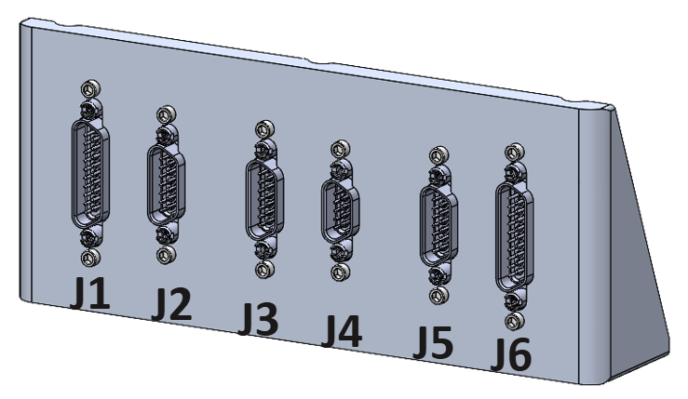
Each connector is a heater zone with corresponding thermistor(s) for that zone. All heaters in a zone are to be controlled as a single heater (all turn on or off at the same time).
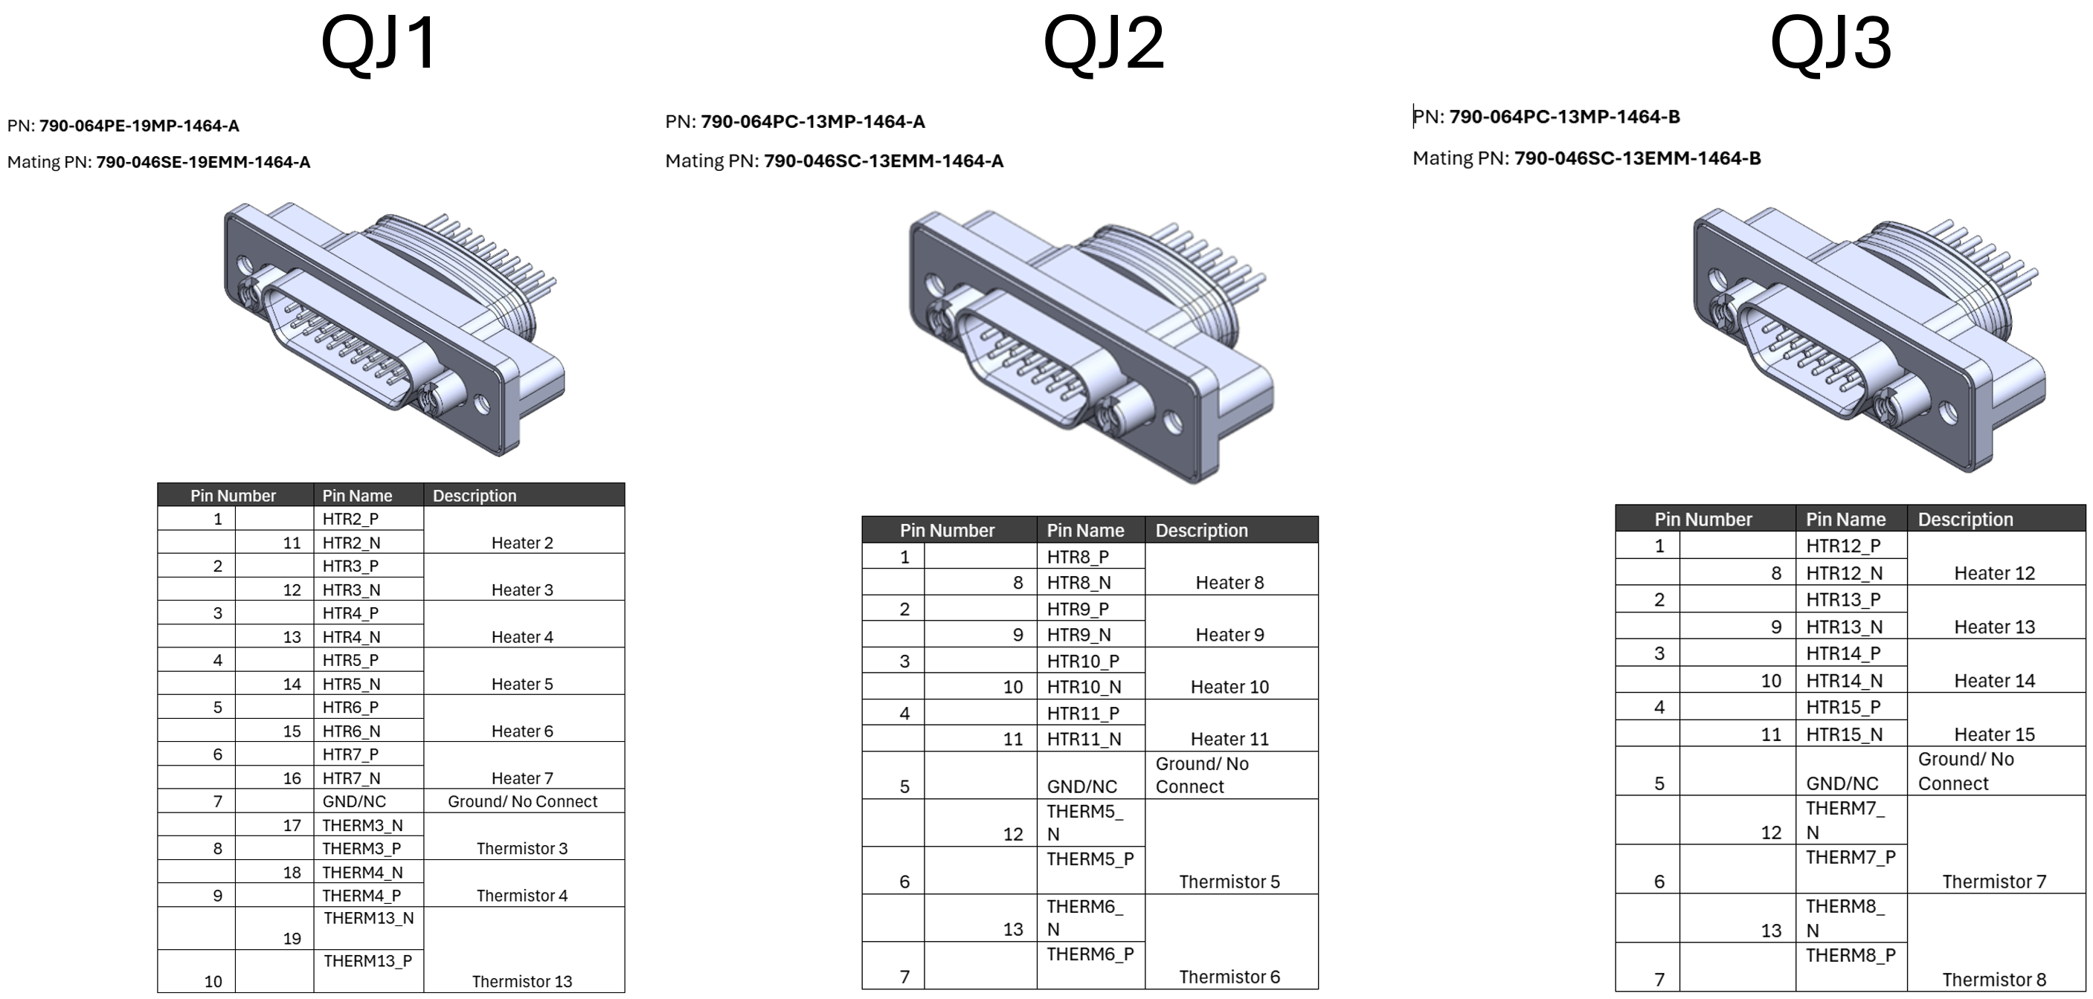
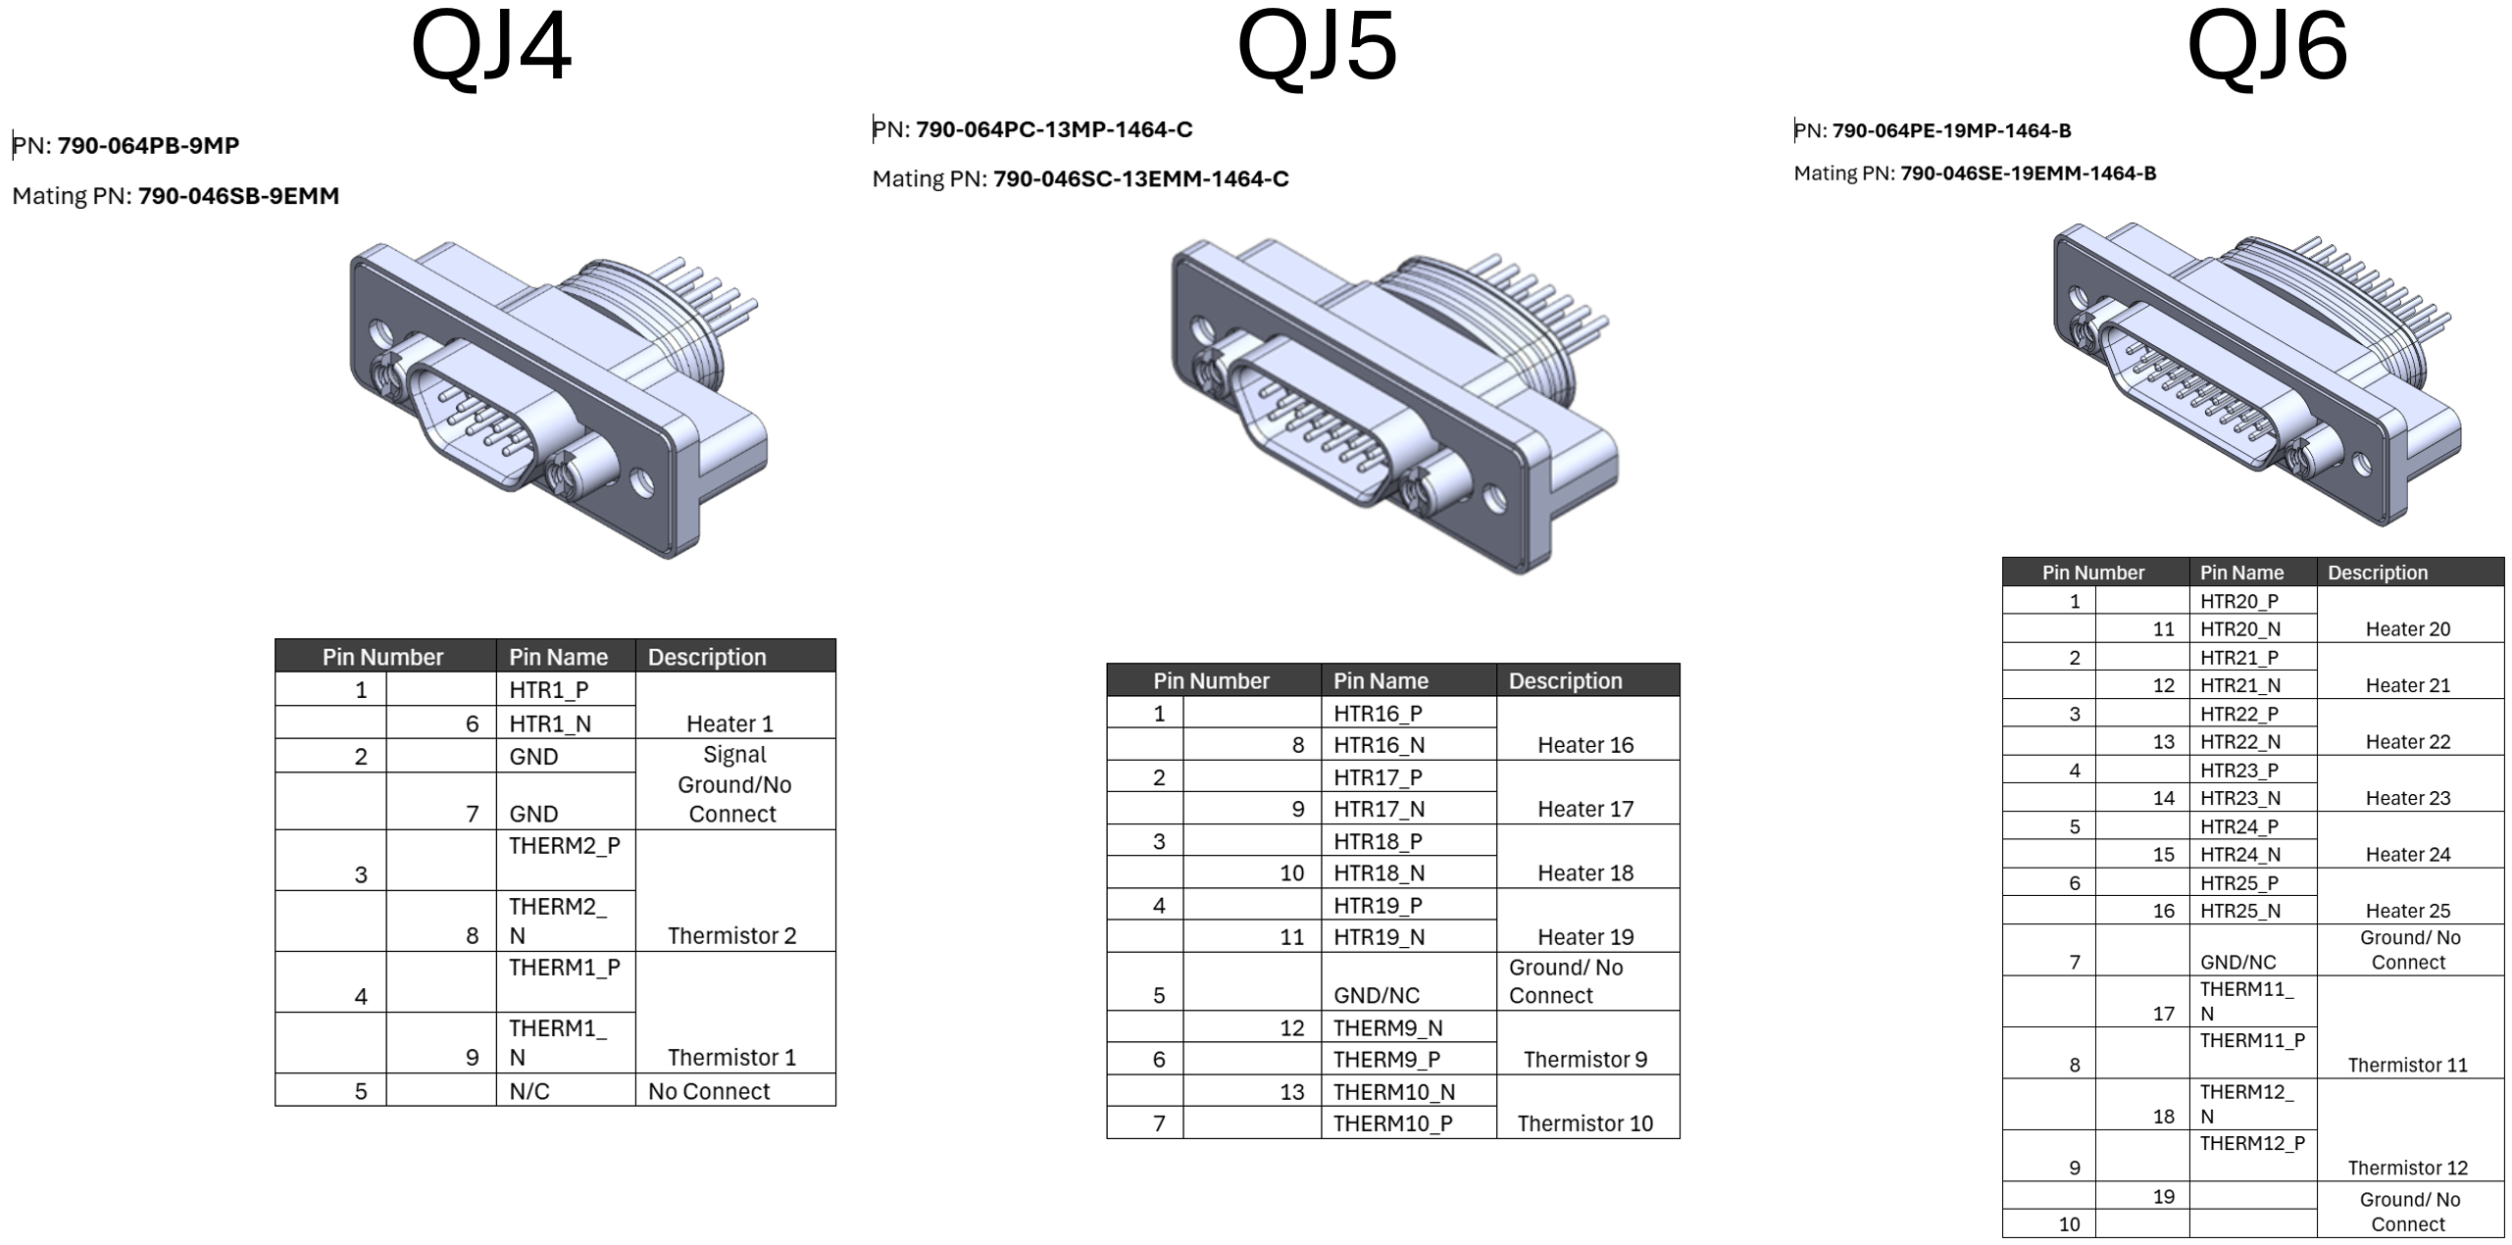
- THERMAL MANAGEMENT

The heater and thermistor interface are meant for the satellite bus to be able to perform thermal management of the FARSIGHT payload. This is the case for both survival (FARSIGHT powered off) and operational (FARSIGHT powered on and operating) temperatures for FARSIGHT.
Except possibly being able to deliver additional temperature sensor readings to the bus, FARSIGHT itself does not perform any thermal management.
Table below shows thermal management set points that will inform the satellite bus thermal management scheme.
Heater Zone | Sensor 1 | Sensor 2 | Sensor 3 | Proportional control % | On Set Point (°C) | Off Set Point (°C) | Critical Set Point  (°C) | Sensor Type
1 | Farsight_Therm1 | Farsight_Therm2 | Farsight_Therm13 | 100 | 10 | 11 | 50 | TH-44004-80-T
2 | Farsight_Therm3 | Farsight_Therm4 |  | 100 | 10 | 11 | 50 | TH-44004-80-T
3 | Farsight_Therm5 | Farsight_Therm6 |  | 100 | 10 | 11 | 50 | TH-44004-80-T
4 | Farsight_Therm7 | Farsight_Therm8 |  | 100 | 10 | 11 | 50 | TH-44004-80-T
5 | Farsight_Therm9 | Farsight_Therm10 |  | 100 | 10 | 11 | 50 | TH-44004-80-T
6 | Farsight_Therm11 | Farsight_Therm12 |  | 100 | 10 | 11 | 50 | TH-44004-80-T
7 | Therm14 |  |  |  |  |  |  | 0118MF

GROUNDING
This section defines the grounding scheme employed in FARSIGHT.
FARSIGHT chassis/shield is isolated from signal ground. Power return is connected to signal ground.
All interfaces between FARSIGHT and the host space vehicle are using differential signaling so signal ground is not available on any control interface connectors. This reduces the risk of unintentional ground paths through signal harnesses.
The remote heater and thermistor interface provided on the FARSIGHT Sensor Board are accessible through the avionics board but are not connected to either FARSIGHT P/SGND or chassis.

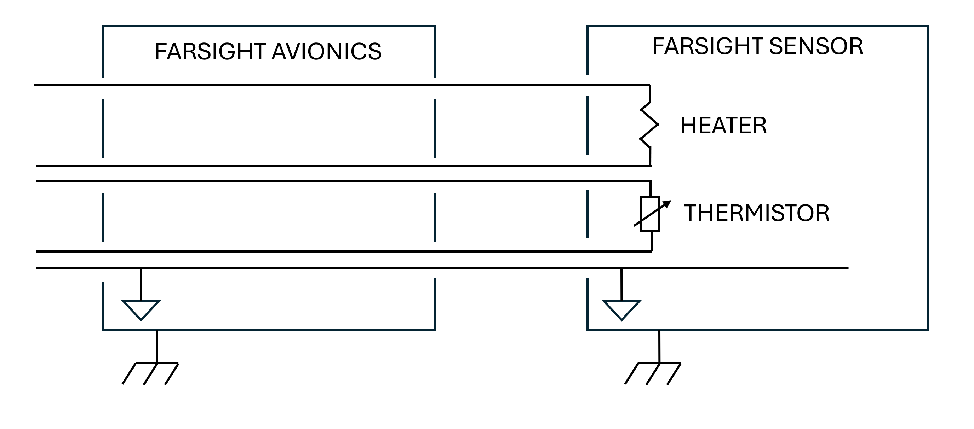
FARSIGHT electrical ground is called signal and power ground, SGND and PGND. These are all the same, but PGND is meant to provide lowest impedance power ground return. Any SGND pin on an interface is meant to be signal return path for surrounding signals.

INTERNAL ELECTRICAL INTERFACE DEFINITIONS

There are a few electrical interfaces that exist inside of FARSIGHT. These include the Avionics board to the Sensor board as well as the Avionics board to the focusing mechanism. These interfaces, along with harness design guidelines are detailed below.

J6: Focusing Mechanism Interface
19 pin female Glenair Series 79 with jack posts.
(Glenair 790-044SE-19MEPA, mating example: Glenair 790-045PE-19MM)
Table 7-1: Focusing Mechanism Interface Pinout
Pin Number |  | Pin Name | Description | Twisted Pair | Functional Group
1 |  | LVDT_S_P | Secondary 1 winding + (red wire) | Pair 0 | LVDT position sensor
 | 11 | LVDT_S_N | Secondary 0 winding + (black wire) | Pair 0 | LVDT position sensor
 |  |  | Secondary 0 winding – (blue wire) | Shorted at LVDT | LVDT position sensor
 |  |  | Secondary 1 winding – (green wire) | Shorted at LVDT | LVDT position sensor
2 |  | LVDT_S_SHIELD | Shield for secondary winding (drain wire) |  | LVDT position sensor
 | 12 | LVDT_P_SHIELD | Shield for primary winding (drain wire) |  | LVDT position sensor
3 |  | LVDT_P_P | Primary winding + (yellow wire) | Pair 1 | LVDT position sensor
 | 13 | LVDT_P_N | Primary winding – (brown wire) | Pair 1 | LVDT position sensor
4 |  | GND | No connect in harness |  | NC
 | 14 | GND | No connect in harness |  | NC
5 |  | GND | No connect in harness |  | NC
 | 15 | GND | No connect in harness |  | NC
6 |  | COIL_SHIELD | Shield for stepper motor harness |  | Stepper motor
 | 16 | SEC_COILB_P | Stepper motor secondary coil B + | Pair 4 | Stepper motor
7 |  | PRIM_COILA_P | Stepper motor primary coil A + | Pair 3 | Stepper motor
 | 17 | SEC_COILB_N | Stepper motor secondary coil B - | Pair 4 | Stepper motor
8 |  | PRIM_COILA_N | Stepper motor primary coil A - | Pair 3 | Stepper motor
 | 18 | SEC_COILA_N | Stepper motor secondary coil A - | Pair 2 | Stepper motor
9 |  | PRIM_COILB_N | Stepper motor primary coil B - | Pair 5 | Stepper motor
 | 19 | SEC_COILA_P | Stepper motor secondary coil A+ | Pair 2 | Stepper motor
10 |  | PRIM_COILB_P | Stepper motor primary coil B + | Pair 5 | Stepper motor

Focusing Mechanism Harness
The harness between J6 and the LVDT and stepper motor is illustrated below in Figure 7-1.
It contains multiple shields for protecting the sensitive LVDT circuitry from the noise in the environment and that generated by the motor driver/coils.
LVDT Secondary negative wires (blue and green wires) should be shorted close to the LVDT housing.
For this purpose the primary and secondary coils of the LVDT are individually shielded and terminated with drain wires to shielded pins in the harness connector, and to grounding lugs near the LVDT housing.
The motor coils also have a shield which is similarly tied off.
To provide complete shield coverage at the harness connector, a short overshield is specified which attaches to the backshell of the connector and makes contact to the 3 shield bundles inside of it, covering the exposed region of the wires and providing a low impedance path to the connector shell.
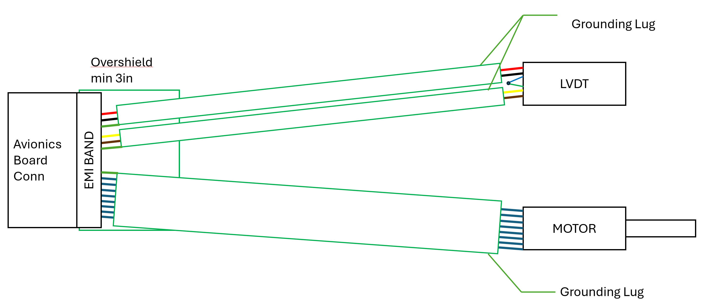
Figure 7-1: Focusing mechanism harness illustration

J7: Sensor Board Interface
69 pin male Omnetics Nano-D High speed connector.
(Omnetics A49256-001, mating harness provided by Turion)
Table 7-2: Sensor Board Interface Pinout
Pin Number |  | Pin Name | Description
1 |  | GND | SLVS-EC Pair 6 Shield
2 |  | SLVS_EC_6_P | SLVS-EC Pair 6 +
3 |  | SLVS_EC_6_N | SLVS-EC Pair 6 -
 | 36 | SLVS_EC_7_P | SLVS-EC Pair 7 +
 | 37 | SLVS_EC_7_N | SLVS-EC Pair 7 -
 | 38 | GND | SLVS-EC Pair 7 Shield
5 |  | GND | SLVS-EC Pair 4 Shield
6 |  | SLVS_EC_4_P | SLVS-EC Pair 4 +
7 |  | SLVS_EC_4_N | SLVS-EC Pair 4 -
 | 40 | SLVS_EC_5_P | SLVS-EC Pair 5 +
 | 41 | SLVS_EC_5_N | SLVS-EC Pair 5 -
 | 42 | GND | SLVS-EC Pair 5 Shield
9 |  | GND | SLVS-EC Pair 2 Shield
10 |  | SLVS_EC_2_P | SLVS-EC Pair 2 +
11 |  | SLVS_EC_2_N | SLVS-EC Pair 2 -
 | 44 | SLVS_EC_3_P | SLVS-EC Pair 3 +
 | 45 | SLVS_EC_3_N | SLVS-EC Pair 3 -
 | 46 | GND | SLVS-EC Pair 3 Shield
13 |  | GND | SLVS-EC Pair 0 Shield
14 |  | SLVS_EC_0_P | SLVS-EC Pair 0 +
15 |  | SLVS_EC_0_N | SLVS-EC Pair 0 -
 | 48 | SLVS_EC_1_P | SLVS-EC Pair 1 +
 | 49 | SLVS_EC_1_N | SLVS-EC Pair 1 -
 | 50 | GND | SLVS-EC Pair 1 Shield
17 |  | GND | Ground
 | 52 | 1V8_IMX | 1.8V supply
18 |  | GND | Ground
 | 53 | 1V1_IMX | 1.1V supply
19 |  | GND | Ground
 | 54 | 1V1_IMX | 1.1V supply
20 |  | GND | Ground
 | 55 | 1V1_IMX_SNS | 1.1V sense
21 |  | GND | Ground
 | 56 | 4V0_REG | 4V supply
22 |  | GND | Ground
 | 57 | 4V0_REG | 4V supply
23 |  | GND | Ground
 | 58 | 3V3_IMX_SNS | 3.3V sense
24 |  | GND | Ground
 | 59 | 2V9_IMX_SNS | 2.9V sense
25 |  | IMX_2V9_EN_BUF | 2.9V power enable
 | 60 | IMX_3V3_EN_BUF | 3.3V power enable
26 |  | IMX_HEATER_N | Sensor board heater -
 | 61 | IMX_HEATER_P | Sensor board heater +
27 |  | GND | Ground
 | 62 | IMX_SPI_XCE_BUF | SPI CE
28 |  | GND | Ground
 | 63 | IMX_SPI_SDO | SPI SDO
29 |  | GND | Ground
 | 64 | IMX_SPI_SCK_BUF | SPI SCK
30 |  | GND | Ground
 | 65 | IMX_SPI_SDI_BUF | SPI SDI
31 |  | GND | Ground
 | 66 | IMX_XCLR_BUF | Sensor CLR
32 |  | GND | Ground
 | 67 | IMX_XTRIG1_BUF | Sensor TRIG1
33 |  | GND | Ground
 | 68 | IMX_TOUT0 | Sensor TOUT0
34 |  | IMX_THERM_N | Sensor Board Thermistor -
 | 69 | IMX_THERM_P | Sensor Board Thermistor +
35 |  | IMX_OSC_EN_BUF | Sensor Board Oscillator Enable

